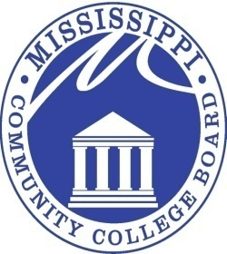

MISSISSIPPI COMMUNITY COLLEGE BOARD

M E E T I N G N O T I C E

FROM: Mr. Kell Smith 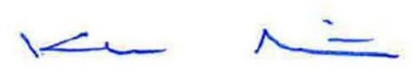
MCCB Executive Director

RE: September 18, 2026 Board Meeting Notice

The regular monthly meeting of the Mississippi Community College Board will be held at 9:00 a.m., CST, Friday, September 18, 2026, at Jones College, located at 900 South Court Street, Ellisville, MS, 39437. This meeting may be conducted as a teleconference meeting.

Missy will be sending hotel information out very soon, as well as a tentative agenda.

3825 RIDGEWOOD ROAD, JACKSON, MISSISSIPPI 39211 601-432-6684

