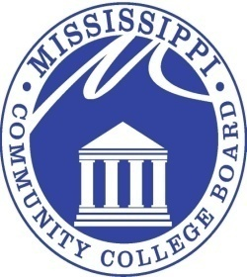

MISSISSIPPI COMMUNITY COLLEGE BOARD

M E E T I N G N O T I C E

FROM: Mr. Kell Smith 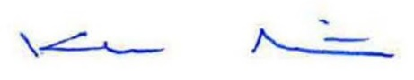
MCCB Executive Director

RE: March 20, 2026 Board Meeting Notice

The regular monthly meeting of the Mississippi Community College Board will be held at 9:00 a.m., CST, Friday, March 20, 2026, in Room 507 of the Paul B. Johnson, Jr. Building, located at 3825 Ridgewood Road, Jackson, MS, 39211. This meeting may be conducted as a teleconference meeting.

Pursuant to the American Disabilities Act of 1990, should you require reasonable disability accommodations for the above meeting, please contact Missy Saxton at 601-432-6684, at least three (3) days before the meeting date.

3825 RIDGEWOOD ROAD, JACKSON, MISSISSIPPI 39211 601-432-6684

